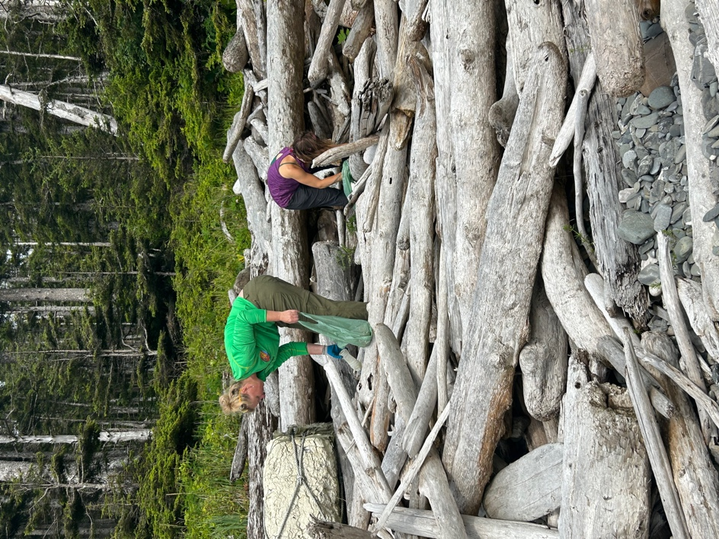

The Landing
Marine Debris Deposition Study
South Kuiu Island, Alaska

Every beach has a story to tell. Every cleanup gives some insight into how debris is deposited and dispersed and the various differences in beach dynamics, but to really understand the story of a particular beach, it takes time.

In addition to the other surveys and beach cleanups that have been done in the six years that the Ikkatsu Project has been visiting South Kuiu Island and Cape Decision, one beach in particular has been singled out to be on the list each year, and detailed results of these annual surveys can be compared with one another. The rationale for the process is, if the beach is cleaned, if all of the debris that can be collected is removed, then whatever is found there when the survey is repeated is known to have come ashore in the intervening time.

The deposition study at the Landing is a part of the beach survey and cleanup program that began in 2018. The Landing was originally chosen for this study because of a relative ease of access, compared with the other possible locations near Cape Decision. There is a trail that runs from the lighthouse to the Landing and although it can be somewhat treacherous, it ensures that there is a route even when the conditions preclude the use of sea kayaks or other craft. In addition, the landing is located on property owned by the Cape Decision Lighthouse Society, a fact that eliminates the need for any other permits and ensures consistency of access. Since the study began, 494 pounds of debris has been collected from this particular beach, while in that same time, 5158 pounds has been removed from the other beaches surveyed in the South Kuiu area.

Thanks to the Cape Decision Lighthouse Society for their partnership and for the use of the lighthouse as a base of operations as the various cleanups and collections have progressed. Likewise, thanks goes out to South Sound Surfrider and Lush Cosmetics, for their roles in supporting the ongoing cleanups and surveys in the area. And a special thanks is in order to all the volunteers who have made the trip, dug through the beach logs and carried the debris up and out on their backs. Like any successful venture, the South Kuiu Cleanup and this deposition study are results of teamwork and this effort has been both efficient and inspirational because of the people involved.

Annual Breakdown

2018
Large debris, including several buoys, assorted metal objects and a metal chair, was collected from the Landing and concentrated in one site above the high tide line for removal in 2019. Smaller items
(total wt. - 48 lbs), were bagged and transported to Wrangell for disposal.

2019
This year’s survey saw a marked decrease in the total amount of debris at the Landing. The 38.5 pounds of debris that was collected included less fishing equipment than was found in 2018, but there was a noticeable increase in plastic beverage bottles.

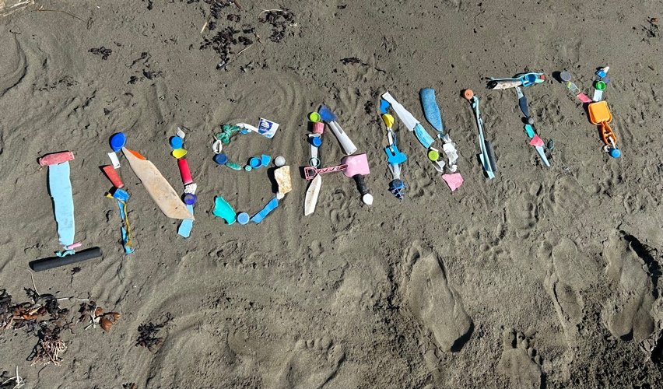
2020
As with seemingly everything else in 2020, the South Kuiu Cleanup was cancelled due to the pandemic. A skeleton crew did make the trip to the lighthouse, however, and while no other beaches were surveyed or cleaned that summer, the deposition study continued. A group of 7 volunteers did a single pass and collected 43 lbs. total.

2021
The 2021 Landing deposition cleanup totaled 114 pounds, and included 15 volunteers doing two full surveys, an initial and a sweep. Foamed plastic debris was heavily represented here, as it was elsewhere, and hard plastic and rope fragments were not difficult to find. No significant large items were found this year and most of the debris that was collected was placed in a supersack at the cache site near the south end of the beach.

2022
A single sweep resulted in 55 lbs. total collected, with a volunteer group of 6 doing the fieldwork. This survey featured the highest number of hard plastic fragments of the six years in the study.

2023
Eight volunteers conducted the initial sweep and an additional pass was done later that same week. A total of 64 lbs. was collected and removed from the Landing, leaving no remaining items at the survey site. All debris was properly disposed of at transfer stations in Petersburg and Tacoma.

Average weight per/yr. - 83.25 lbs.

Notes and Findings

The six most-common items that have been found so far during the deposition study include the following:

ITEM | 2018 | 2019 | 2020 | 2021 | 2022 | 2023
Plastic fragments (hard) | 24 | 27 | 23 | 114 | 139 | 54
Plastic fragments (foamed) | 25L | 11L | 30L | 28L | 3L | 5L
Beverage bottles | 9 | 22 | 36 | 25 | 12 | 17
Bottle or container caps | 5 | 1 | 9 | 17 | 12 | 6
Plastic rope/small net pieces | 12 | 0 | 8 | 28 | 14 | 28
Buoys and floats | 11 | 2 | 5 | 17 | 12 | 17

- The types of items collected varied considerably, although the majority that were picked up were made of some sort of plastic or combination of plastics.
- There is a consistent presence of foamed plastic at the Landing (as with all of the other beaches surveyed), but the marked increase in the total amount in 2018, 2020 and 2021 is likely due to one or more larger foam buoys being broken apart on-site by wave action.
- Beverage bottles, most commonly water bottles, range from complete bottles that can appear almost new to wave-worn fragments that may only constitute a portion of the original bottle. If a piece of debris is identifiable as a beverage bottle, it has been counted as such, even if it is not intact. (A number of the hard plastic fragments collected likely began as parts of bottles.)
- The jump in total numbers for some items (notably between 2020 and 2021/2022), is possibly a result of winter storms that exposed items previously covered by logs. While the numbers for larger items stayed fairly stable during that time, smaller things like plastic and rope fragments increased, which suggests that they may have already been on site.
- The overall numbers for plastic rope have seen an increase in the 3 years beginning in 2021. Most of the pieces collected are the short segments of yellow rope cast off by the oyster industry, most likely US and Canadian in origin.
- The numbers for buoys and floats also increased over the past 3 samples, following the same trend as found with plastic rope fragments. While some of the buoys are completely anonymous, most items found in this category originate in Asia.
- In general, the identifiable items that are found tend to be of more durable construction. Plastic buoys, buckets, ropes and similar items hold up in this environment for longer than thinner, less substantial objects. Items that are regularly seen on cleanups in the lower 48 - straws, plastic utensils, food wrappers and bags, most notably - are hardly represented at all.

Moving Forward

Looking ahead to 2024 and beyond, the deposition study will continue as part of each summer's South Kuiu Cleanup. There is a unique value in keeping a running record of the debris that comes ashore at a particular site and each additional observation increases the value of the data. It would be helpful if the survey could be conducted more frequently - every month, for example - but given the operating limitations that come with working in such a remote location, the current once-a-year program is expected to continue.

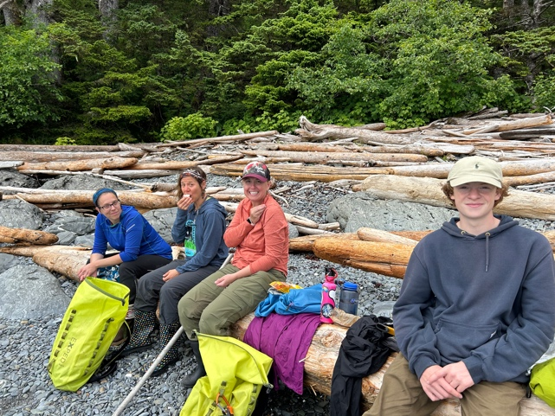
Going forward, special attention will be given to the increase in items related to the fishing industry noted over the past three surveys. These results could be highly localized or they may indicate wider trends; it is difficult to state with any certainty at the this time.

Many of the plastic bottles that are retrieved are of Asian origin. One of the things that will be done in 2024 and beyond is to catalog the bottles that are found, note their specific origin (country and company), and present the responsible parties with evidence of their impact.

On several occasions, items that were found had obviously entered the water from a cruise ship. As in the case of the beverage bottles, items that can be directly tied to a specific cruise line could also be specificaly documented and returned to the source, with details about where they were found, providing information that could lead to solutions.

DEPOSITION TOTALS 2018 - 2023
The Landing, South Kuiu Island, Alaska

Totals for each item found are listed below. (Totals for foamed plastic are given in liters.) The overall numbers include some items that make only a handful of appearances, while others are more abundant, year-to-year.

 | 2018 | 2019 | 2020 | 2021 | 2022 | 2023
Plastic fragments (hard) | 24 | 27 | 23 | 114 | 139 | 54
Plastic fragments (foamed) | 25L | 11L | 30L | 28L | 3L | 5L*
Plastic Fragments (film) | 2 | 0 | 2 | 7 | 2 | 4
Food wrappers | 0 | 0 | 1 | 2 | 0 | 0
Beverage bottles | 9 | 22 | 36 | 25 | 12 | 17
Other jugs or containers | 5 | 3 | 0 | 8 | 5 | 15
Bottle or container caps | 5 | 4 | 9 | 17 | 12 | 6
Disposable cigarette lighters | 0 | 0 | 0 | 4 | 4 | 1
Bags | 1 | 0 | 1 | 1 | 0 | 0
Plastic rope/small net pieces | 12 | 9 | 8 | 28 | 14 | 28
Buoys and floats | 11 | 6 | 5 | 17 | 12 | 17
Fishing lures and line | 0 | 1 | 0 | 2 | 2 | 0
Plastic utensils | 0 | 0 | 2 | 0 | 0 | 0
Straws | 0 | 0 | 0 | 2 | 0 | 1
Personal care products | 0 | 0 | 2 | 3 | 0 | 1
Plastic toys | 0 | 1 | 0 | 2 | 0 | 1
Aerosol cans | 0 | 1 | 4 | 0 | 0 | 1
Metal fragments | 6 | 3 | 0 | 7 | 2 | 1
Glass fragments | 0 | 0 | 5 | 0 | 0 | 0
Flip flops/slippers | 1 | 0 | 2 | 2 | 0 | 6
Rubber fragments | 1 | 2 | 1 | 2 | 0 | 5
Paper and cardboard | 0 | 0 | 2 | 0 | 0 | 0
Lumber and building material | 5 | 2 | 0 | 1 | 3 | 2
Clothing and shoes | 0 | 1 | 1 | 1 | 3 | 1
Rope/net pieces (non-nylon) | 3 | 0 | 2 | 0 | 0 | 0
Fabric pieces | 0 | 0 | 0 | 0 | 0 | 1
WEIGHT TOTAL | 185 | 38.5 | 43 | 114 | 55 | 64

